Minimum Office Equipment Required for On-boarding
Before your new employee arrives, consider the minimum equipment that he or she will need to be successful, comfortable and safe in their new work environment.
At a minimum, for each laptop or desktop computer issued, the hiring department must pay for and provide the following, as needed:
- An external keyboard,
- An external mouse,
- One or more external monitor(s) mounted on a height-adjusted base, if available
In addition, the employee must be provided with an appropriate desk and/or a workstation that is ergonomically designed. Newer industry standard desks that can accommodate the computer equipment are acceptable. Low “typewriter” desk wings are not acceptable.
In the event that a new employee has a special need for ergonomic equipment beyond the minimum requirements listed above, one of the following must be done to obtain this equipment:
- Conduct an ergonomic evaluation by a College-sponsored ergonomist to establish the needed equipment, or
- The employee must provide a note from a medical doctor or a physician (such as a primary care physician or a specialist, but not a chiropractor or a Doctor of Chiropractic) requiring such equipment for health reasons.
The Environmental Health & Safety Department may provide additional standard-issue ergonomic equipment, as needed, such as computer peripherals, document holders, special chairs, desks, etc., but not beyond the pre-approved models. Also, if a new employee requires dual monitors or a special desk model because of its size, functionality or other features related to his/her duties, then the hiring department must provide and pay for this equipment. At no time shall employees be required to use their own equipment.
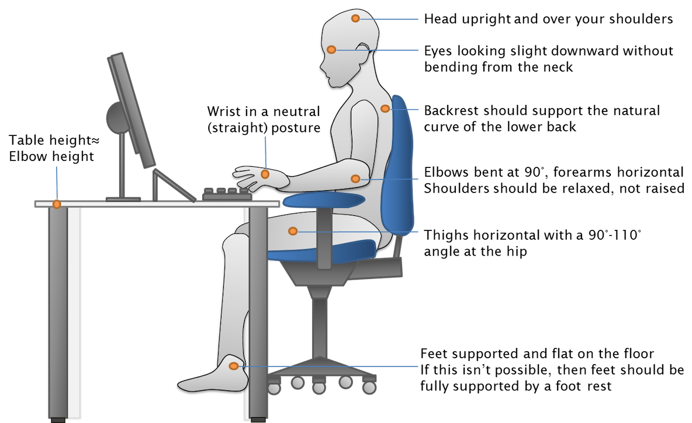
For ergonomic evaluations, questions regarding ergonomic equipment and/or general health and safety-related issues, please contact Safa Toma, Director of Environmental Health & Safety at 631-8287, or sat5@stmarys-ca.edu.
Monitor at fingertip distance

